目 錄

前言 3
身心障礙者權利公約(CRPD)第二次國家報告國際審查會議議程 7
國際審查委員會介紹 9
參與身心障礙者權利公約(CRPD)第二次國家報告國際審查會議相關訊息及注意事項 21
場地平面圖 33
身心障礙者權利公約及會議相關文件QR code 36

Contents

Preface | 5
Agenda for Review Meeting of ROC’s 2nd Report under the CRPD | 8
International Review Committee | 10
Notice for participation at the Review Meetings of the ROC’s Second Report under the Convention on the Rights of Persons with Disabilities | 27
Floor Plan | 33
QR code for Documents related to CRPD and the Meeting | 36

前言

身心障礙者權利公約（Convention on the Rights of Persons with Disabilities，以下簡稱CRPD）於2006年12月13日在聯合國大會議定通過，並於2008年5月3日正式生效，係21世紀的第一個國際人權條約，旨在促進、保障與確保身心障礙者充分、平等享有所有人權及基本自由，並促進對身心障礙者固有尊嚴之尊重，影響著全球身心障礙者權利甚鉅。

我國於2007年修正公布之身心障礙者權益保障法，即納入CRPD精神與內容，將其轉化為具體法規條文，並配合各項國際身心障礙議題與公約內容修正。為進一步強化身心障礙者權益保障及與國際人權體系接軌，2014年8月1日立法院三讀通過身心障礙者權利公約施行法（以下簡稱CRPD施行法），同年8月20日總統公布，並自2014年12月3日國際身心障礙者日施行，由各級政府機關依法共同推動CRPD權益保障事項。

依據CRPD施行法第7條第1項規定：「政府應依公約規定建立身心障礙者權利報告制度，於本法施行後二年提出初次國家報告；之後每四年提出國家報告，並邀請相關專家學者及民間團體代表審閱。」我國CRPD初次國家報告於2016年12月2日公布，2017年邀請5位國際專家來臺審查，會後提岀85點結論性意見，做為我國檢討及修正相關法令、政策或行政措施之參考；過去4年當中，各部會已依國際專家提出的結論性意見調整與發展身心障礙領域相關政策，未來也會有步驟、有策略地積極努力推動各項工作，讓我國無障礙環境日趨完善，身心障礙者能獨立生活、充分平等參與社會。

身心障礙者權利公約第二次國家報告於2020年12月1日公布，原定2021年11月辦理「身心障礙者權利公約第二次國家報告國際審查會議」，惟受COVID-19影響，經討論後延期至2022年8月1日至3日辦理，本次亦邀請5位具相關背景或熟悉公約審查作業之國際專家組成「CRPD第二次國家報告國際審查委員會」，審閱我國CRPD第二次國家報告。5位審查委員包含主席長瀨修教授（日本籍）、Joseph P. Kennedy Jr.國際基金會資深研究員Diane Richler（加拿大籍）、前澳洲心理衛生及精神復健非政府組織Flourish Australia主任Janet Meagher（澳洲籍）、前聯合國CRPD委員會委員金亨植教授（澳洲籍）、英國Doughty Street律師事務所律師Oliver Lewis（英國籍）。會議由國際審查委員會與政府代表、民間團體針對身心障礙人權重要議題進行建設性對話，藉以瞭解我國落實CRPD現況、檢視尚待改進之處並提供具體建議。希冀藉由本次國際審查過程，以展現我國推動CRPD之努力及積極參與國際人權事務之決心，並依據審查委員的結論性意見檢討、研擬後續施政，更加保障我國身心障礙者之權益。

Preface

The Convention on the Rights of Persons with Disabilities (CRPD) was adopted by the United Nations General Assembly on 13 December 2006 and entered into force on 3 May 2008, and is the first international human rights treaty of the 21st century. It aims to promote, protect and ensure the full and equal enjoyment of all human rights and fundamental freedoms by persons with disabilities, and to promote respect for their dignity. Its impact on the rights of people with disabilities worldwide has been significant.

Taiwan’s People with Disabilities Right Protection Act was revised and promulgated in 2007. The revision incorporated the spirit and content of the CRPD and took into account international disability issues and treaties. In order to further strengthen the protection of the rights of people with disabilities and to align with the international human rights system, on 1 August, 2014, the Legislative Yuan passed the Act to Implement the Convention on the Right of Persons with Disabilities (hereinafter referred to as the Act to Implement on CRPD) on third reading, which was promulgated by the President on August 20 of the same year. The law has been in force since International Day of Persons with Disabilities on December 3, 2014. The authorities at all levels of government work together to promote the protection of the rights of CRPD in accordance with the law.

According to Article 7(1) of the Act to Implement on CRPD, "The government shall establish a reporting system regarding the rights of persons with disabilities. The first national report shall be submitted within two years from the implementation of this act. Thereafter, national reports shall be filed every four years. Relevant academic experts and representatives from private organizations shall be invited to review the reports." Taiwan's initial national report on CRPD was published on December 2, 2016, and in 2017, five international experts were invited to Taiwan to review the report and provide 85 concluding observations, which will serve as a reference for Taiwan to review and amend relevant laws, policies or administrative measures. Over the past four years, various ministries have adjusted and developed policies in the field of disabilities in accordance with the Concluding Observations made by international experts. In the future, the Taiwanese government will take steps, strategies and active efforts to promote an accessible environment in Taiwan, therefore, people with disabilities can live independently and participate fully and equally in society.

The Second Report under CRPD was published on 1 December 2020 and the international review meeting of the Second Report under CRPD was originally scheduled for November 2021. However, due to the impact of COVID-19, the meeting was postponed to 1-3 August 2022 after discussion. Five international experts familiar with CRPD review procedures or from relevant fields are invited to form an International Review Committee. The five reviewers are: Professor Nagase Osamu (Japan), the Chairperson of International Review Committee; Ms. Diane Richler, C.M. (Canada), Senior Research Fellow of Joseph P. Kennedy Jr. International Foundation; Janet Meagher AM (Australia), the former General Manager of Flourish Australia, an Australian mental health and psychiatric rehabilitation NGO; Professor Hyung-Sik Kim (Australia), former member of the CRPD Committee of the United Nations, and Dr. Oliver Lewis (United Kingdom), a barrister of Doughty Street Chamber. The meeting will be a constructive dialogue between the International Review Committee, government agencies and civil society organizations on important issues such as human rights for the disabilities challenged, with the aim of understanding the current status of CRPD implementation in Taiwan, examining areas for improvement and providing specific recommendations. Through this international review meeting, we hope to demonstrate Taiwan's efforts to promote CRPD and its determination to actively participate in international human rights affairs, and to review and develop follow-up measures based on the Concluding Observations to strengthen the protection of the rights of people with disabilities in Taiwan.

身心障礙者權利公約(CRPD)第二次國家報告國際審查會議議程
日期 | 時間（UTC+8） | 活動 | 備註
7/31 (日)  第1天 | 18:00 - 20:00 | 歡迎晚宴
8/1 (一)  第2天 | 09:00 -09:30 | 開幕式 | 公開  (視訊時間  09:00 - 10:30、11:00 - 12:30、14:00 - 15:30，  計4.5小時)
 | 09:30 -10:00 | 委員會與立法委員及國家人權委員會會議
 | 10:00 - 10:30 | 非政府組織代表發表聲明
 | 10:30 - 11:00 | 休息
 | 11:00 - 12:30 | 委員會與非政府組織會議（一）
 | 12:30 - 14:00 | 休息
 | 14:00 - 15:30 | 審查身心障礙者權利公約：  條文1~11
 | 15:30 - 16:00 | 休息 | 不公開*
 | 16:00 - 17:30 | 書面審查
8/2 (二)  第3天 | 09:00 - 10:30 | 委員會與非政府組織會議（二） | 公開  (視訊時間  09:00 - 10:30、11:00 - 12:30，  計3小時)
 | 10:30 - 11:00 | 休息
 | 11:00 - 12:30 | 審查身心障礙者權利公約：  條文12~22
 | 12:30 - 14:00 | 休息 | 不公開*
 | 14:00 - 17:00 | 書面審查
8/3 (三)  第4天 | 09:00 - 10:30 | 委員會與非政府組織會議（三） | 公開  (視訊時間  09:00 - 10:30、11:00 - 12:30，  計3小時)
 | 10:30 -11:00 | 休息
 | 11:00 - 12:30 | 審查身心障礙者權利公約：  條文23~33
 | 12:30 - 14:00 | 休息 | 不公開*
 | 14:00 - 17:00 | 書面審查
8/4 (四)  第5天 | 擬具結論性意見 |  | 不公開*
8/5 (五)
第6天
8/6 (六)  第7天 | 14:30-15:30 | 結論性意見發布記者會 | 公開  (視訊時間  14:30 - 15:30，計1小時)
 | 15:30-16:30 | 歡送茶會 | 不公開*
Agenda for Review Meeting of ROC’s 2nd Report under the CRPD
Date | Time (UTC+8) | Description | Note
Sunday,  July 31st, 2022 | 06:00pm - 08:00pm | Welcome Reception | Private event
Monday,  August 1st, 2022 | 09:00am - 09:30am | Opening Ceremony | 4.5 hours.  public online meeting
 | 09:30am - 10:00am | Meeting with Legislative Yuan and National Human Rights Commission
 | 10:00am - 10:30am | NGO Declaration
 | 10:30am - 11:00am | Break
 | 11:00am - 12:30pm | Meeting with NGOs (Cluster I)
 | 12:30pm - 02:00pm | Break
 | 02:00pm - 03:30pm | Review of Article 1-11
 | 03:30pm - 04:00pm | Break | Private*
 | 04:00pm - 05:30pm | Paper Review
Tuesday,  August 2nd, 2022 | 09:00am - 10:30am | Meeting with NGOs (Cluster II) | 3 hours.  public online meeting
 | 10:30am - 11:00am | Break
 | 11:00am - 12:30pm | Review of Article 12-22
 | 12:30pm - 02:00pm | Break | Private*
 | 02:00pm - 05:00pm | Paper Review
Wednesday, August 3rd, 2022 | 09:00am - 10:30am | Meeting with NGOs (Cluster III) | 3 hours.  public online meeting
 | 10:30am - 11:00am | Break
 | 11:00am - 12:30pm | Review of Article 23-33
 | 12:30am - 02:00pm | Break | Private*
 | 02:00pm - 05:00pm | Paper Review
Thursday,  August 4th, 2022 | Drafting and Adopting of Concluding Observations |  | Private*
Friday,
August 5th, 2022
Saturday,  August 6th, 2022 | 02:30pm - 03:30pm | Press Conference and Presentation of Concluding Observations | Public  event
 | 03:30pm - 04:30pm | Farewell Reception | Private event

國際審查委員會介紹
International Review Committee

長瀨修
Osamu Nagase
（日本）
現職
- 日本立命館大學生存學研究中心榮譽教授
- 國際融合組織秘書長
- 東亞障礙研究論壇聯合主席
- 日本社會障礙研究學會國際委員會主席
- 日本障礙論壇CRPD委員會副主席
- 障礙平等培訓論壇董事會成員
- 《障礙與社會》編輯
- 《障礙與社會正義國際期刊》編輯

專業經驗
長瀨教授的多年職涯經歷包括協助發展肯亞的志願者（日本國際協力機構喬莫·肯雅塔 (Jomo Kenyatta) 農業和技術學院）、日本身心障礙議員的正式秘書、國際身心障礙者組織（DPI）亞太區計畫辦事員、聯合國秘書處於奧地利和美國身心障礙計畫的初階專業專家、聯合國於柬埔寨的和平大使（柬埔寨過渡時期聯合國權力機構）、巴勒斯坦的選舉監督員（為日本外務省）、東京大學的副教授，以及2017年中華民國（臺灣）CRPD初次國家報告國際審查委員會主席。

長瀨教授撰寫了諸多關於障礙研究和CRPD的文章，並在亞洲、歐洲和南美洲就CRPD演講和主持研討會。

Osamu Nagase
(Japan)
Current Position
- Eminent Research Professor at Institute of Ars Vivendi, Ritsumeikan University (Kyoto, Japan)
- Secretary-General of Inclusion International
- Co-Chair, East Asia Disability Studies Forum
- Chair, International Committee, Japan Society for Disability Studies
- Vice-Chair, CRPD Committee, Japan Disability Forum
- Board member, Disability Equality Training Forum
- Editor, Disability & Society
- Editor, International Journal of Disability and Social Justice

Professional Experience
His long career includes development volunteer in Kenya (Jomo Kenyatta College of Agriculture and Technology for Japan International Cooperation Agency), official secretary to a member of parliament with disabilities in Japan, Asia Pacific programme officer of Disabled Peoples’ International (DPI), Junior Professional Officer with the disability programme of U.N. Secretariat in Austria and U.S., U.N. peace keeper in Cambodia (UNTAC), election monitor in Palestine (for the Ministry of Foreign Affairs of Japan), associate professor at the University of Tokyo, as well as the chair of International Review Committee for the initial review of the CRPD of the Republic of China (Taiwan) in 2017. He has authored many articles on disability studies and the CRPD, and given presentations and led workshops on CRPD in Asia, Europe and South America.

Diane Richler, C.M.
（加拿大）
現職
- 甘迺迪基金會（Joseph P. Kennedy Jr. Foundation）資深國際政策研究員
- 國際融合組織─促進融合教育主席

專業經驗
- 甘迺迪基金會（Joseph P. Kennedy Jr. Foundation）資深國際政策研究員（2012至今）
- 國際融合組織-促進融合教育主席（2017至今）
- 全球障礙行動網絡（GLAD Network）─融合教育工作小組聯合主席（2019-2022）
- 聯合國教科文組織全球教育監測報告 (GEM) 專家審查委員（2020）
- 中華民國（臺灣）CRPD初次國家報告國際審查委員（2017）
- 開放社會基金會─人權倡議董事（2012-2016）
- 魯德曼基金會國際諮詢委員會委員（2016-2018）
- 國際身心障礙者聯盟（IDA）主席（2010-2012）
- 國際融合組織會長（2002-2010）
- Erasmus Mundus全球高等教育計畫融合教育領域，訪問學者，捷克查理斯大學（Charles University）（2007-2008）
- 《身心障礙者權利公約》協商期間的民間社會領袖（1999-2006）
- 加拿大社區生活協會執行長（1987-2001）
- 羅赫研究所（Roeher Institute）主任（1984-1987）

Diane Richler, C.M.
(Canada)
Current Position
- Senior International Policy Fellow, Joseph P. Kennedy, Jr. International Policy
- Fellow Chair, Inclusion International Catalyst for Inclusive Education

Professional Experience
- Senior International Policy Fellow, Joseph P. Kennedy, Jr. International Policy Fellow (2012-present)
- Chair, Inclusion International’s Catalyst for Inclusive Education (2017-present)
- Co-chair, GLAD Network Working Group on Inclusive Education (2019-2022)
- Member, expert review committee, UNESCO Global Education Monitoring Report (GEM) (2020)
- Member, International Review Committee, CRPD, Republic of China (Taiwan) (2017)
- Advisory Board member, Human Rights Initiative of the Open Society Foundation (2012-2016)
- Member, International Advisory Council of the Ruderman Foundation (2016-2018)
- Chair, International Disability Alliance (IDA) (2010-2012)
- President of Inclusion International (2002-2010)
- Erasmus Mundus Visiting Academic in inclusive education, Charles University, Czech Republic (2007-2008)
- Civil society leader in the negotiation of the CRPD (1999-2006)
- Chief Executive Officer, Canadian Association for Community Living (1987-2001)
- Director of The Roeher Institute (1984-1987)

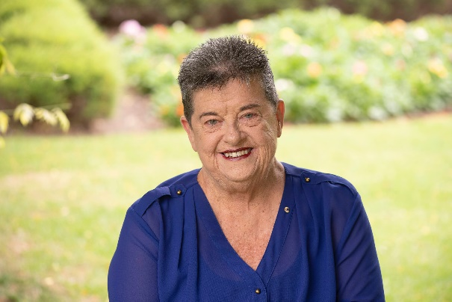 | Janet Meagher AM  （澳洲）
目前參與的活動
- 澳洲身心障礙者暴力忽視及剝削防治皇家委員會：戰略參與小組
- 維多利亞州心理健康系統皇家委員會（2019-2021）：證人和顧問
- 澳洲無障礙交通工作小組委員：審查及改革《無障礙公共交通的障礙標準》
- 澳洲身心障礙者保險計畫心理健康諮詢小組委員
- 澳洲身心障礙者保險計畫獨立諮詢顧問（2015-2021）
- 世界心理衛生協會-大洋洲心理衛生諮詢委員
- 澳洲衛生部社會心理支持小組委員
- 澳洲衛生部心理健康改革小組委員

專業經驗
50多年來，Meagher女士致力於人權保障者，作為教師和圖書管理員，她在身心障礙和精神健康領域，也被公認為是一名活動暨倡權者。

Meagher女士是澳洲精神障礙者運動的創始人之一，並在國內和國際上推動心理健康宣導及心理社會障礙者權利。在廣泛的身心障礙領域中，她在各個層面及各種障礙類型的參與都得到廣泛的認可。

自1970年初，Meagher女士便與思覺失調症共存，且因為曾被安置於機構中，她成為一名活動暨倡權人士，一直致力於為身心障礙者和精神障礙者爭取權利和公平、參與和尊重。

獲得獎項
由於Meagher女士受人尊敬和無畏的工作精神，於 1996 年被授予澳洲勳章 （AM），並在 2017 年獲得國家心理健康獎。

Meagher女士在1994年獲得邱吉爾獎學金，並曾在英國、美國和加拿大進行考察，研究精神障礙者充權和自我倡議，並撰寫了《Partnership or Pretence: a handbook of empowerment and self advocacy for consumers of psychiatric services and those who provide or plan those services》（該書亦譯被為西班牙語和日語）。

參與組織及活動
- 澳洲心理健康委員會委員（2012-2014）
- 世界心理衛生聯盟：董事會成員和秘書（1996-2005）
- Flourish Australia 主任（2001-2013）
- 著有《澳洲同儕工作》（2018）、《希望、力量和決心（Ho》（2022）

Meagher女士目前參與的各項活動都與實踐身心障礙者權利公約及將其納入國家立法、政策和支持做法有關，並促使政府改變態度及重視公約，更積極地落實公約並且讓障礙者充分參與。

Janet Meagher AM
(Australia)
Current Involvements
Enquiry:
- Royal Commission into Violence, Abuse Neglect and Exploitation of people with Disabilities: Strategic Engagement Group
- Royal Commission into Victoria's Mental Health System (2019-2021): Witness and advisor

Advice:
- National Accessible Transport Taskforce: Subject Matter Expert. To review and reform the Disability Standards for Accessible Public Transport
- National Disability Insurance Scheme - Mental Health Sector Advisory Group
- National Disability Insurance Scheme -Independent Advisory Council Member (2015-2021)
- World Federation for Mental Health- Oceania Mental Health Advisory Committee
- Australian Department of Health- Psychosocial Support Advisory Group
- Australian Department of Health- Mental Health Reform Stakeholder Group

Professional Experience
Janet Meagher is a Human Rights protector and has been so, for over 50 years. A teacher and librarian by profession, she has been long recognised as an activist and advocate in both the disability and mental health sectors.

Ms. Meagher was one of the founders of the mental health consumer movement in Australia and has promoted mental health advocacy and psychosocial disability rights nationally and internationally. Her involvement in the disability sector and participation at all levels and across disability types is widely acknowledged.

She has lived with schizophrenia since the early 1970s, and, as a result of institutionalization she became an activist and advocate has worked for rights and equity, participation and respect for people living with disabilities and those with mental health issues.

AWARDS
For her respected and fearless work Ms. Meagher was honoured as a Member of the Order of Australia (AM) in 1996, and was the recipient of the National Mental Health Prize in 2017.

She was awarded a Churchill Fellowship in 1994. Her study tour across UK, USA and Canada investigated Consumer Empowerment and Self Advocacy, and subsequently she authored “Partnership or Pretence : a handbook of empowerment and self advocacy for consumers of psychiatric services and those who provide or plan those services” (translated into Spanish and Japanese).

INVOLVEMENTS
- National Mental Health Commissioner (2012-2014)
- World Federation for Mental Health: Board Member and Secretary (1996-2005)
- Director Inclusion, for Flourish Australia (2001-2013)
- Contributor and editor of books “Peer Work in Australia” (2018), “Hope, Strength and Determination” (2022)

All of Janet’s current activity and involvements are related to implementing and imbedding CRPD in National legislation, policy and support practices and in reforming attitudes and priorities in government for better practices and involvement of people with disabilities in improving conformity with CRPD.

金亨植
（澳洲）
專業經驗
- 澳洲莫納什大學社會政策博士
- 韓國社會工作、倫敦政治經濟學院社會管理文憑
- 英國曼徹斯特大學社會管理碩士
- 社會政策及國際合作退休榮譽教授

- 曾任教於澳洲昆士蘭大學、莫納什大學和埃迪斯可文大學（1975-1994）
- 曾於首爾中央大學和韓國高麗大學國際研究學部教授社會政策、障礙研究和國際合作等科目（1995-2016）
- 曾於倫敦政治經濟學院擔任客座教授（2009）
- 臺灣伊甸基金會CRPD實務研究中心諮詢專家（2014-2018）
- 韓國紐約州立大學的首席教授（2016-2019）
- 韓國國家人權中心國際委員會成員和顧問
- 越南（國際非政府組織）、衣索比亞、緬甸雷傷者專案的國際扶輪全國秘書
- 全球祝福（Global Blessing）顧問（北韓障礙者人權的國際非政府組織）

金亨植教授在國際合作、人權和身心障礙研究領域有廣泛的研究和教學工作，著有12本書及諸多期刊文章，包括關於《聯合國障礙者權利公約》之專書，及2019年出版《由福利到人權：聯合國障礙者權利公約深/申論》。

Hyung-Shik Kim
(Australia)
Professional Experience
- Ph D in Social Policy (Monash University, Australia)
- Social Work (Korea), Graduate Diploma in Social Administration (London School of Economics and Political Science)
- MS.C in Social Administration (Manchester)
- Professor Emeritus in Social Policy, International Cooperation

- Queensland, Monash and Edith Cowan Universities (1975-1994)
- Teaching Social Policy, Disability Studies, and International Cooperation at Chung-ang, and Korea University of International Studies, Seoul (1995-2016)
- Visiting Professor at LSE (2009)
- Disability Rights Consultant with Eden International Foundation, Taiwan (2014-2018)
- Leading Professor, New York State University in Korea (2016-2019)
- Korea National Human Rights Institute, Committee Member and Advisor
- RI National Secretary, Project Director, Landmine Disability Project in Vietnam (INGO), Ethiopia, Myanmar
- Global Blessing, Consultant (A North Korean Disability Human Rights ING)

Some 12 books and numerous articles in refereed journals, including a 400 page book on “UN Disability Rights Convention: A Commentary-from Welfare to Human Rights”(2019)

Oliver Lewis
（英國）
Oliver Lewis為英國倫敦Doughty Street律師事務所的訴訟律師，關注英國及國際上的醫療照護和障礙法。

直到2017年，Lewis律師擔任心智障礙倡議中心（Mental Disability Advocacy Centre, 現更名為Validity）的執行長，並監督世界上最大的國際障礙者權利訴訟案件。他具有在歐洲人權法院、聯合國及歐洲理事會之訴訟及辯護經驗，曾參與聯合國《身心障礙者權利公約》的起草協商，並就公約的實施著有大量的專題文章。

Lewis律師是里茲大學法學院法律和社會正義碩士學位（學程）的客座教授。他是英國社會福利機構Respond的董事會主席，該機構旨在幫助經歷過創傷的學習障礙者，他也是Bristol法律中心的董事會主席。

Oliver Lewis
(United Kingdom)
Oliver is a barrister at Doughty Street Chambers, London, UK. His practice focuses on healthcare and disability law, both in the UK and internationally.

Until 2017, he was Executive Director of the Mental Disability Advocacy Centre (now ‘Validity’), and oversaw the world’s largest international disability rights docket.

He has experience of litigation before the European Court of Human Rights as well as advocacy before UN and Council of Europe bodies. He participated in the negotiation of the UN Convention on the Rights of Persons with Disabilities (CRPD) and has written widely on its implementation.

Oliver is Visiting Professor of Law and Social Justice at the School of Law at the University of Leeds. He is the Chair of the Board of Trustees at Respond, a UK charity that helps people with learning disabilities who have experienced trauma, and Chair of the Board of Trustees of Bristol Law Centre.

參與身心障礙者權利公約(CRPD)第二次國家報告國際審查會議相關訊息及注意事項

身心障礙者權利公約（以下簡稱CRPD）第二次國家報告國際審查會議（以下簡稱本會議）舉行期間，為使會議順利進行及促進國際人權交流，強化國際參與，特訂定本注意事項。

- 會議時間及地點
本會議訂於111年8月1日至8月3日假南港展覽館2館7樓701AB室（臺北市南港區經貿二路2號）舉行，並於6樓602室進行同步轉播。
- 會議秘書單位
由衛生福利部社會及家庭署擔任本會議之秘書單位。
- 會議場次
本會議包括「國際審查委員與立法委員及國家人權委員會會議」場次、「非政府組織代表發表聲明」場次、「審查國家報告」場次及「委員會與民間團體對話」場次。
- 會議入場條件
具備下列資格之一者，得申請參與本次會議
- 有提出CRPD第二次國家報告之平行報告。
- 有提出CRPD第二次國家報告問題清單之平行回復。
- 非透過秘書單位轉送平行報告或問題清單平行回復，但有提出已自行送交國際審查委員之證明資料（如通信紀錄）。
- 曾出席CRPD第二次國家報告撰寫階段之審查會議。
倘申請參與之人數眾多，將依前開順序安排進入主會場，並於會議召開前於CRPD資訊網公告入場名單。

- 會議發言須知
- 「國際審查委員與立法委員及國家人權委員會會議」場次及「非政府組織代表發表聲明」場次：
- 兩場次合併報名，共開放90個名額入場，每1民間團體至多推派3位代表，主會場中至少提供1個座位，該場次座位不足時，其他代表至同步轉播室。
- 國際審查委員與立法委員及國家人權委員會會議場次：由立法院代表或國家人權委員會代表發言，團體代表可入場旁聽，不開放發言。
- 非政府組織代表發表聲明場次：由民間團體推派代表發言，各民間團體申請發表者，請於報名時繳交「非政府組織聲明稿」（附錄1-非政府組織代表發表聲明稿），秘書單位將於彙整後，召開「民間團體發言協調會」，民間團體應依協調結果之順序進行發言。
- 審查國家報告場次：
- 由政府機關代表答復國際審查委員之提問，每場次開放90個名額入場旁聽，不開放發言（每1民間團體至多推派3位代表入場，主會場中至少提供1個座位，該場次座位不足時，其他代表將安排至同步轉播室）。
- 會議原則上依條文順序逐條審查，配合國際審查委員意見調整。
- 委員會與民間團體對話場次：
- 由民間團體代表與國際審查委員進行對話，每場次開放90個名額。若一份民間報告由數個民間團體共同撰寫，參與撰寫之民間團體皆可推派代表出席，每1民間團體至多推派3位代表入場，主會場中至少提供1個座位，該場次座位不足時，其他代表安排至同步轉播室。
- 民間團體申請與國際審查委員進行對話，請於報名時同步填寫「民間團體場次發言單」（如附錄2-委員會與民間團體對話發言單）。秘書單位將於彙整「民間團體場次發言單」後，召開「民間團體發言協調會」，民間團體應依協調結果之順序進行發言。
- 每1民間團體限發言1次，發言順序及預估可發言時間，由秘書單位公布於CRPD資訊網；各民間團體應依公布之順序發言，但實際發言情形，仍需視本次會議進行狀況由主席決定。
- 上述可入場應於本次會議報到時，憑身分證件換發入場證，會議進行期間，進入主會場均應配戴入場證，未配戴者不得自行入場。
- 未能入場者可至同步轉播室或本次會議專屬網站觀看直播。
- 會議報名
- 本次會議以網路報名方式為限，報名連結及期限將另行公布於CRPD資訊網。各場次均須事先報名，不接受現場報名，逾期不受理。
- 參與者若需要協助，請務必於報名時說明需求內容。
- 其他事項
- 會議各公開場次將由秘書單位拍攝、錄影、錄音並進行網路直播，出席者視同授權秘書單位運用其照片或視訊影像於各種媒體管道公開發表。另為尊重個人隱私，請勿於未經許可之狀況下拍攝出席者並逕自公布予社群媒體。
- 請出席者務必配合秘書單位防疫規劃，詳細內容將併同報名資訊公布於CRPD資訊網。
- 為尊重國際審查委員會及與會人員，所有入場人員應避免出現干擾或破壞會場秩序之行為，維持互相尊重之會場秩序。
- 配合疫情，會議舉辦之期程及場地如有異動，將於調整後儘速公告周知。

附錄1-非政府組織代表發表聲明稿

身心障礙者權利公約（CRPD）第二次國家報告國際審查會議
非政府組織代表發表聲明稿
單位名稱：（中文）
（英文）
發言序號：
（由秘書單位填寫）
摘要（約300字）
（請摘要說明聲明之內容，建議同時以中、英文敘述，未提供英文者，由秘書單位委託翻譯社翻譯逕送予國際審查委員，並副知提供發言單之民間團體。）

附錄2-委員會與民間團體對話發言單
身心障礙者權利公約（CRPD）第二次國家報告國際審查會議
委員會與民間團體對話發言單
單位名稱：（中文）
（英文）
發言日期： | 發言場次： | 發言序號：  （由秘書單位填寫）
一、摘要（約300字）
二、上述摘要所涉及之公約條文、結論性意見與建議、一般性意見或其他參考文件（必填，並請依發言內容與各該條文、結論性意見與建議或一般性意見之關聯性由高至低排序）
（一）
（二）
（三）
（四）
（五）
三、附件（如有附件請註明附件名稱）
（一）
（二）
（三）
（四）
（五）
四、注意事項
（一）每一場次請分別填列發言單，並請務必註明場次資訊，未列入發言順序之民間團體，本發言單仍將轉送國際審查委員參酌。
（二）請摘要說明欲與國際審查委員對話之內容，建議同時以中、英文敘述，未提供英文者，由秘書單位委託翻譯社翻譯逕送予國際審查委員，並副知提供發言單之民間團體。
（三）建議提供對話內容所涉及之公約條文、一般性意見或其他參考文件。其他有利審查之佐證資料建議一併提供。

Notice for participation at the Review Meetings of the ROC’s Second Report under the Convention on the Rights of Persons with Disabilities

The following guidelines were established for the Review Meeting of the Second Report under Convention on the Rights of Persons with Disabilities (CRPD) (hereafter “the meeting”) to ensure the smooth execution of the meeting, promote international communication regarding human rights, and encourage international engagement.

- Date and Venue
The meeting is scheduled to take place at Room 701AB, Taipei Nangang Exhibition Center, Hall 2 (TaiNEX2, No. 2, Jingmao 2nd Road, Nangang District, Taipei City) on August 1–3, 2022, and Room 602 is selected for a live simulcast and livestream.

- Secretariat of the Meeting
The secretariat is the Social and Family Affairs Administration of the Ministry of Health and Welfare.

- Sessions
The meeting comprises the Meeting with Legislative Yuan and National Human Rights Commission sessions, NGO Declaration session, Report Review sessions (hereafter “the government session”) and Meeting with NGOs sessions (hereafter “the NGO session”).

- Registration Eligibility
Those who satisfy any of the following criteria may apply to participate in the meeting:
- Submitted a parallel/alternative report for the Second Report;
- Submitted a parallel/alternative reply to the List of Issues for the Second Report;
- NGOs that did not submit their parallel/alternative report or reply through the secretariat but able to provide proof (e.g., emails) of direct submission to the International Review Committee;
- Participated in the review meeting during the drafting phase of the Second Report;
If the number of applied participants is overly large, an arrangement will be made for the participants to enter the main venue in accordance with the previously mentioned sequence. A list of admitted participants will be announced on the CRPD website prior to the meeting.

- Guidelines to Taking the Floor
- “Meeting with Legislative Yuan and National Human Rights Commission” session and “NGO Declaration” session:
- Participants of these two sessions only need to register once. A total of 90 participants are allowed. Each NGO may send at most 3 representatives. The main venue will provide at least 1 seat for each organization. When the number of seats is insufficient, other representatives will be invited to a simulcast room.
- “Meeting with Legislative Yuan and National Human Rights Commission” session: Representatives of the Legislative Yuan or National Human Rights Commission will give speeches. NGO representatives may enter the session and listen without speaking.
- “NGO Declaration” session: Representatives of NGO will give speeches. Applicants must submit their summary for declaration (Appendix 1) when registering for the session. After the Secretariat compiles all declarations, it will convene a coordination meeting for the participating organizations, the representatives of which will speak in the sequence determined during that meeting.
- Government sessions:
- Governmental authorities shall answer questions posed by the International Review Committee members. Each session allows 90 participants to listen without speaking. Each NGO may send at most 3 representatives to participate in the session. The main venue will provide at least 1 seat for each organization. When the number of seats is insufficient, other representatives will be invited to a simulcast room.
- The articles will be reviewed in the order of which they appear in the report and be adjusted according to the opinion of International Review Committees.
- NGO sessions:
- When NGO applies for conversing with International Review Committee members, it must fill out a discussion form (Appendix 2). After the Secretariat receives the form from all participating NGOs, it will convene a coordination meeting. The NGO representatives will speak in the sequence determined during the meeting.
- NGO representatives will discuss with the International Review Committee. Each session admits 90 participants. If a report is jointly composed by multiple NGOs, each NGO may send at most 3 representatives to participate in the session. The main venue will provide at least 1 seat for each organization. When the number of seats is insufficient, other representatives will be invited to a simulcast room.
- Each NGO may speak once. The sequence of and estimated time allocated for each speaker will be announced by the Secretariat on the CRPD website. In general, NGO representatives will speak in accordance with the announced sequence. However, the chairperson may adjust the sequence when needed.
- NGO representatives must identify themselves with their ID Card when they sign in to the sessions and wear the attendee badge at all times in the main venue. Those not wearing the attendee badge will be refused entry.
- Those who cannot enter the main venue may participate in the sessions in the simulcast room or through the livestream on the webpage of the meeting.

- Registration
- Participants may only register for the conference through the Internet. The registration link and deadline will be announced on the CRPD website. All sessions require registration in advance and do not accept onsite registration. Late applications will be rejected.
- If a participant requires any assistance, please describe his or her need during the registration.

- Others
- All public meeting sessions will be photographed, video- and audio-recorded, and livestreamed. By participating in the sessions, the attendees authorize the secretariat to publish photos or videos of them on all media channels. To protect the attendees’ privacy, please do not take photos, videos or audio-records of attendees without their permission and publish them on social media.
- All attendees must follow the secretariat’s COVID-19 pandemic protocol, which will be detailed on the CRPD website along with the registration information.
- To show respect for the International Review Committee members and attendees, all personnel entering the venue must refrain from disrupting the order of speakers during the sessions. Mutual respect must be maintained at the venue.
Any changes to the time and venue of the meeting will be announced as quickly as possible once determined.

Appendix 1: Summary for NGO Declaration
NGO’s Declaration for Review Meetings of the ROC’s Second Report under the Convention on the Rights of Persons with Disabilities
(NGO Declaration Session)
Name of NGO:
Order of discussion:
(be filled up by secretariat)
Summary of declaration (approximately 300 words)
(Please summarize the expected content of the discussion with the International Review Committee. NGOs are suggested provide both Chinese and English versions of their summary. For those that do not provide an English version, the secretariat will commission a translation company to translate their summary and submit the translated version directly to the International Review Committee, with a copy also provided to the NGO)

Appendix 2: Discussion Form
Discussion Form for Review Meetings of the ROC’s Second Report under the Convention on the Rights of Persons with Disabilities
(NGO sessions)
Name of NGO:
Date: | Session: | Order of discussion:  (be filled up by secretariat)
1. Summary of discussion (approximately 300 words)
2. Convention articles, concluding observations, recommendations,
general comments, and documents related to the said summary

(5)

3. Attachments (please specify the name of the attachment, if any)

4. Notice
- Please submit a separate Discussion Form for each session and provide the information for each session on each form. For NGOs not included in the discussion or given the floor at the sessions, the Application Form for Discussion will still be forwarded to the International Review Committee for their reference.
- Please summarize the expected content of the discussion with the International Review Committee. NGOs are suggested provide both Chinese and English versions of their summary. For those that do not provide an English version, the secretariat will commission a translation company to translate their summary and submit the translated version directly to the International Review Committee, with a copy also provided to the NGO.
- NGOs are suggested to provide all convention articles, general comments, and reference documents included in the discussion. Please also provide any official documents that would facilitate the review process.

場地平面圖
Floor Plan
附圖一 南港展覽館2館7樓7F, Taipei Nangang Exhibition Center, Hall 2
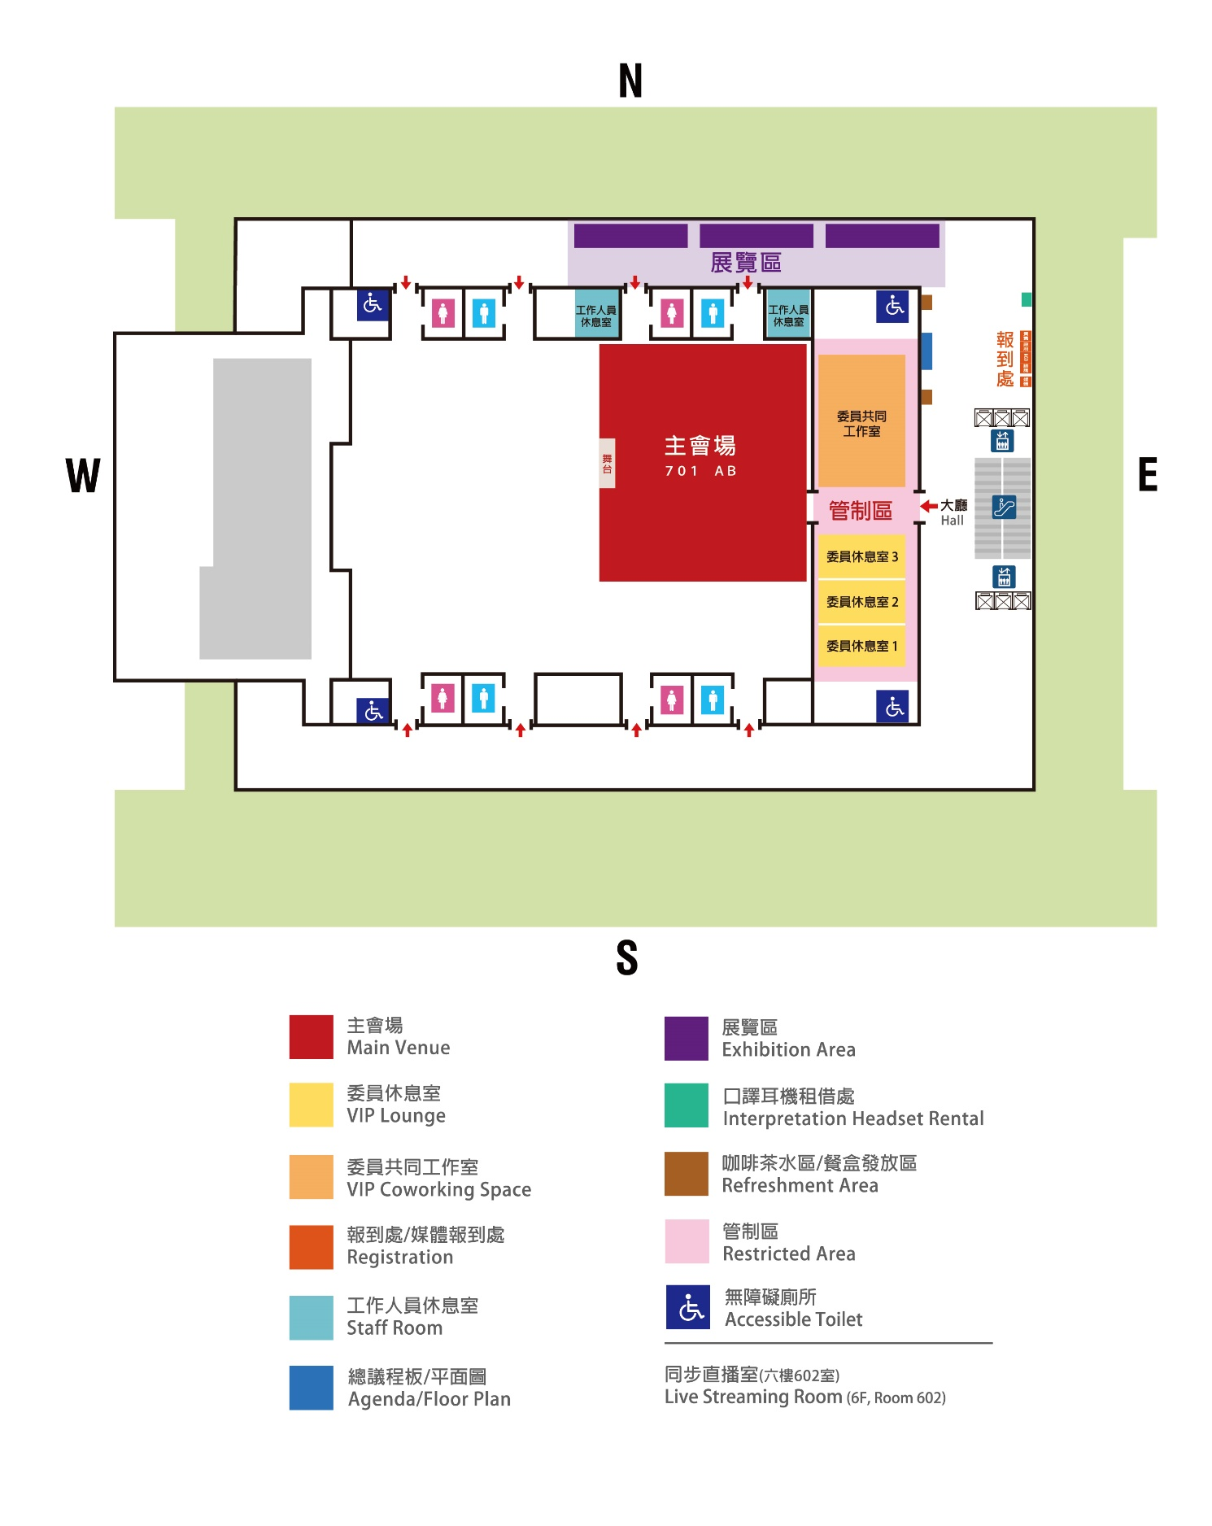
附圖二 主會場Main Venue
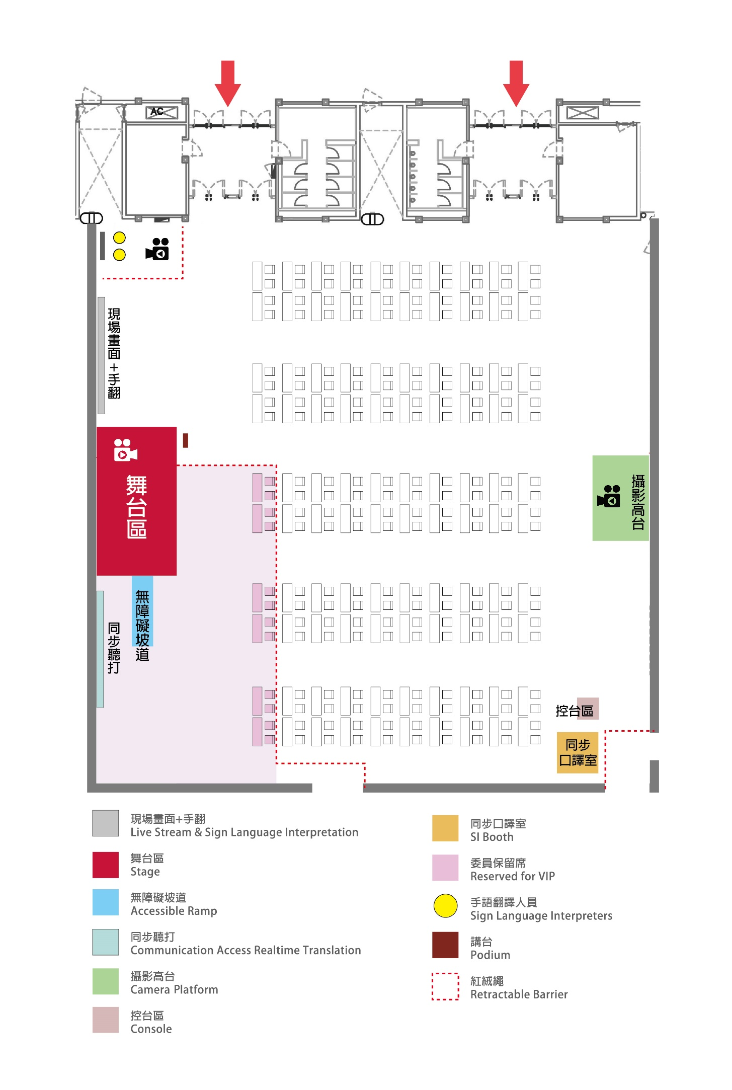
無障礙廁所
Accessible Toilet
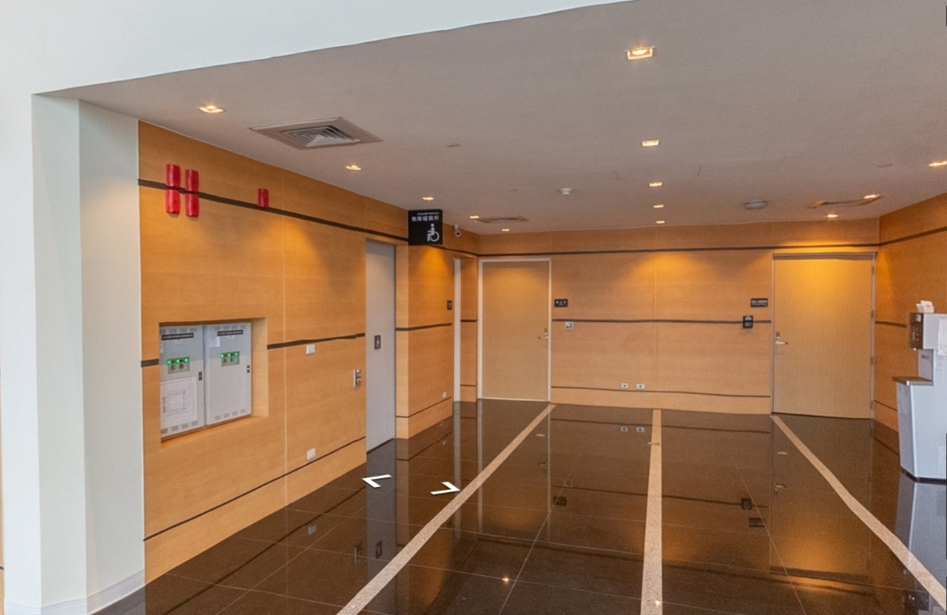

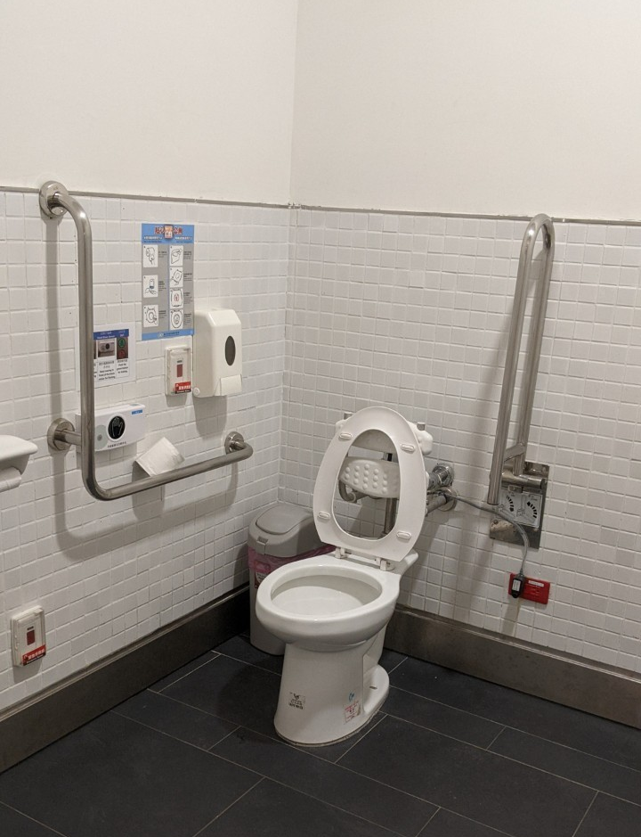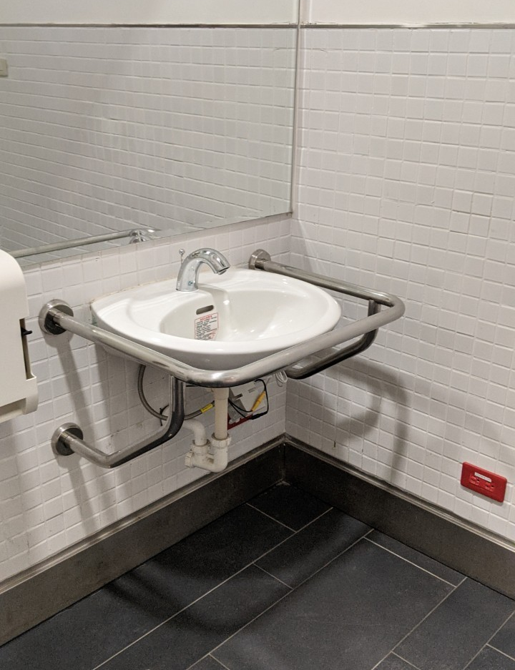
備註：除七樓外，於六樓(1間)、四樓(2間)、地下一樓(2間)及地下二樓(2間)皆有無障礙廁所可供使用。
Note：Accessible toilets are available on 7F, 6F (1 room), 4F (2 rooms), B1 (2 rooms) and B2 (2 rooms).

身心障礙者權利公約及會議相關文件QR code
QR code for Documents related to CRPD and the Meeting
身心障礙者權利公約（中譯本修正草案）
Convention on the Rights of Persons with Disabilities (Amendment Draft in Chinese)
身心障礙者權利公約（臺灣手語版）
Taiwan Sign Language Version of the CRPD
身心障礙者權利公約（易讀版）
Easy-Read Version of the CRPD
身心障礙者權利公約施行法
Act to Implement the Convention on the Right of Persons with Disabilities
CRPD第二次國家報告專要文件
Implementation of the CRPD Second Report
CRPD第二次國家報告專要文件（有聲書版）
Audio Version of the Implementation of the CRPD Second Report
CRPD第二次國家報告專要文件（臺灣手語版）
Taiwan Sign Language Version of the Implementation of the CRPD Second Report
CRPD第二次國家報告專要文件（易讀版）
Easy-Read Version of the Implementation of the CRPD Second Report
CRPD第二次國家報告民間團體平行報告
2021 Parallel Report on CRPD
CRPD第二次國家報告國家人權委員會獨立評估意見
Opinions on the Second National Report of Republic of China (Taiwan) on the Rights of Persons with Disabilities
English  中文 | CRPD第二次國家報告問題清單  List of issues in relation to the second report of the Republic of China (Taiwan)
CRPD第二次國家報告問題清單及政府機關回應內容
Replies of Taiwan to the List of Issues in Relation to Its Second Report under the CRPD
CRPD第二次國家報告問題清單國家人權委員會及民間團體平行回復
Replies of National Human Rights Commission and Taiwan NGOs to the List of Issues in Relation to Its Second Report under the CRPD
CRPD第二次國家報告國際審查會議-會議議程、參與會議相關訊息及注意事項
Agenda, Information and Guidelines for Review Meeting of ROC’s 2nd Report under the CRPD

